

Datathon Competition

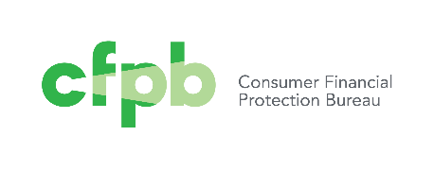

**Bureau of Consumer Financial Protection**

The following link contains more than one million data points of consumer complaints from the CFPB. The role of this bureau is to assist consumers who have complaints on financial products and services from multiple corporations.

<https://catalog.data.gov/dataset/consumer-complaint-database#topic=consumer_navigation>

You can do your own research for additional data points and figures when it comes to consumer complains on financial products and it is suggested that you do.

**Problem statement**

Using the above data source and any others from your own research, create analytics and make conclusions so that you can advise cfpb on its future plans, actions, and legislation proposals so that this market becomes more efficient and the number of consumer complaints decreases.

Specifically, identify the products, sub-products, issues and sub issues as well as corporations and sub sectors that create most problems for the consumers. Search through the consumer text narratives to identify the top areas of consumer complaints.

Identify all possible factors, existing in this dataset or not, that have the highest impact in leading to consumer complaints. Provide advice to the federal government and propose five specific pieces of legislation to the US Congress.